Building a Culture of Peace in the GTA

Check out our exciting peacebuilding workshops below!

To bring one or more of these workshops in your community, send us an email at community@interchange4peace.org

- Active Citizenship: Becoming active in constructing a culture of human rights. Facilitator: Sara Korosi

- Animating The Golden Rule Workshop: Exploring the universal ethic of reciprocity “The Golden Rule.” Facilitator: Tina Petrova

- Building a Global Culture of Human
Rights.
Facilitator: Sara Korosi

- Connecting Across Differences: Learning how to make the difference you want with others. Facilitator: Henry Wai

- Deliberative Dialogue Processes for Learning & Peace-building: Introducing the deliberative dialogue processes for transforming conflict.
Facilitator: Melissa Abramovitz

- Drama for Peacebuilding:
Facilitator: Frangess Kohi

- Engaging Conflict and Transforming Relationships through Dialogue Circles: Facilitator: Melissa Abramovitz

- Health & Happiness Workshop: Relieve stress and improve clarity of thought.
Facilitators: The Art of Living Teachers of the
Art of Living Foundation.

- I Am a Peace-Builder – A Self-Reflective Workshop.
Facilitator: Um’Khonde Patrick Habamenshi

- I am a Peace-Builder/Wounded Healer--Playing with Pictures: Use images to explore conflict and peacebuilding.
Facilitator: Jessica Outram

- Introduction to International Humanitarian Law.
Facilitator: Sara Korosi

- Peace begins at home: A series of 5 sessions of about 2 ½ hrs. each for students, parents/guardians, teachers, Principal, police, members of the community.
Facilitators: Anne Goodman & Michael Wheeler

- Peace Literacy: Customizable single workshop of 2 ½ hrs. or a series of workshops exploring
a culture of peace & different kinds of violence. Facilitator: Anne Goodman

- Peace Literacy for Artists and Educators & Arts Educators Workshop: For working artists, teachers, and arts educators.
Facilitator: Ezra Houser

- Peace Facilitation: Claim and frame your own work as Peacebuilding.
Facilitator: Ezra Houser

- The Explosive Remnants of War and Children affected by Armed Conflict.
Facilitator: Sara Korosi

- Stiltdancing for confidence and mutual empowerment: A physical activity session with mind-body centering techniques.
Facilitator: Ezra Houser

- What is Peace? Playing With Words: Using poetry to explore peacebuilding.
Facilitator: Jessica Outram

- Sri Sri Yoga Workshop
Facilitators: The Art of Living Teachers, Art of
Living Foundation

- The Mask and The Shield – A Self-Reflective Workshop.
Facilitator: Um’Khonde Patrick Habamenshi

- Trauma Healing: Customizable single workshop of 2 ½ hrs. or a day-long workshop or a whole weekend (or Friday evening, all-day Saturday). Exploring concepts such as types of trauma, trauma release exercises.
Facilitator: Anne Goodman

- Transforming Communities Through Solution Focused Interventions.
Facilitator: Fatima Peermohamed

- Power-with: Realising Feedback’s Untapped Potential. In this workshop, participants will learn a 3 steps process for giving positive feedback.
Facilitator: Henry Wai

Building a Culture of Peace in the GTA

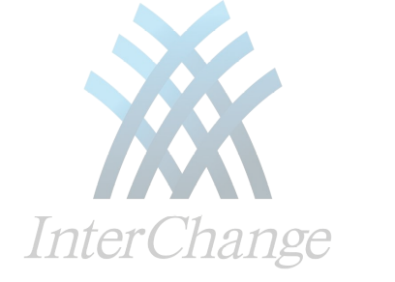InterChange’s Building a Culture of Peace in the GTA is an education and training programme that offers peace-building workshops to leaders and members of communities who want to foster a culture of peace.

For more information about this program and the workshop facilitators, check out our website:
http://www.interchange4peace.org

To bring these workshops in your community, please send us an email at community@interchange4peace.org

InterChange
c/o Transformative Learning Centre
(Room 7-165)
Department of Adult Education
and Counselling Psychology
Ontario Institute of Studies in Education
University of Toronto
7th floor, 252 Bloor St. West
Toronto ON M5S 1V6, Canada

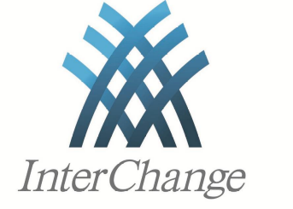

Building a Culture of Peace in the GTA

Are you a community organization or project interested in hosting a peace-building workshop in your community?

Check inside for more information on our workshops and how to bring them to your community!

http://www.interchange4peace.org

